Title in English

Título en español

Título em português

Author 1  Affiliation  City, Country  e-mail | Author 2  Affiliation  City, Country  e-mail
Author 3
Affiliation
City, Country
e-mail

Abstract
Your abstract must be no more than 300 words. The abstract should highlight the issue that is the focus of the paper, the goal of the study, the method used to achieve this goal, and the main results and contributions. If your paper was written in English, you only need to present the abstract and keywords in English. If the paper is in Spanish or Portuguese, you should also include a version of the abstract and keywords in the language you wrote the paper. To take full advantage of this template, please copy your manuscript’s content and paste it as unformatted text over the corresponding sections in this document.
Keywords: List up to five keywords that describe your paper, separated with “;”

Resumen
Su resumen no debe tener más de 300 palabras. El resumen debe resaltar el tema que es el foco del trabajo, el objetivo del estudio, el método utilizado para lograr este objetivo y los principales resultados y contribuciones. A excepción del resumen y las palabras clave, que deben presentarse en inglés y en el idioma del artículo, el resto del texto puede estar en español, portugués o inglés. La intención de este documento es proporcionar una plantilla ya formateada cuyo texto pueda ser reemplazado fácilmente por los autores para enviar su trabajo a RELCASI. Por favor copie el contenido de su manuscrito y péguelo como texto sin formato en las secciones correspondientes de este documento.
Palabras clave: Enumere hasta cinco palabras clave que describan su trabajo, separadas por “;”
Resumo
Seu resumo não deve ter mais que 300 palavras. O resumo deve destacar a questão que é o foco do trabalho, o objetivo do estudo, o método usado para atingir esse objetivo e os principais resultados e contribuições. Com exceção do resumo e das palavras-chave, que devem ser apresentados em inglês e no idioma do artigo, todo o restante do texto pode estar em espanhol, português ou inglês. A intenção deste documento é fornecer um modelo já formatado cujo texto pode ser substituído facilmente pelos autores para submeter seu trabalho à RELCASI. Por favor, copie o conteúdo do seu manuscrito e cole-o como texto não formatado nas seções correspondentes deste documento.
Palavras-chave: Liste até cinco palavras que descrevem seu trabalho, separadas por “;”

Introduction
This document presents the basic guidelines for structuring and formatting a manuscript to be submitted to RELCASI. The journal publishes theory-driven complete research and research-in-progress papers, as well as teaching cases and descriptions of innovative IT projects, in which the role of the broader institutional and socioeconomic Latin American and Caribbean context is clearly and explicitly addressed.
Research papers must be academically rigorous without sacrificing clarity, style, and simplicity and offer a practical contribution that will make them attractive to practitioners.
The introduction situates the paper within the broader IS field and its traditions, as well as within the current industry practices. It puts forth the study’s objective and relevance for Latin American and Caribbean researchers, professionals, organizations, governments, and populations. It should also underline the contribution of the paper to scholars and practitioners.

Theoretical background/Literature review
In this section, you should present the theories and concepts that underpin the study. It introduces state-of-the-art research on the issues that were investigated, and builds the argument to support the study’s hypotheses.

Method
The section clearly describes the research method used in the study, including sources of information, participants/respondents, data collection instruments and techniques, data analysis procedures and related software, and triangulation, and other methods employed to ensure the validity of the findings.

Results
In this section, you should detail your findings. Quantitative papers must provide detailed enough information to support the claims made in the study. Qualitative papers must provide adequate empirical evidence to support the arguments and interpretations developed by the authors.

Discussion
The discussion should compare and contrast the results of the study with the extant literature. It identifies and discusses points of conflict and consensus and suggests explanations for unexpected results. Alternative explanations for the findings of the study should be presented when applicable.

Conclusion
Authors should present the contributions of the study to the IS field and discuss the connections of their findings with the political, economic, social, technological, environmental, and legal context of Latin America and the Caribbean and/or their implications for Latin American and Caribbean researchers, practitioners, organizations, governments or societies. They should also discuss the limitations of their study and suggest directions for future research.

Formatting and style
This section presents guidelines for preparing papers for submission, as far as formatting and writing style are concerned.
Normal text would look like this. Underlines are never used; italics and bold may be used to emphasize words or statements with discretion. Please keep emphasis to an absolute minimum.

Formatting
Manuscripts must be formatted as follows:
- Page size: A4
- Margins:
- Top and left: 2,5 cm
- Right and bottom: 2 cm
- Title
- Font: Arial bold
- Size: 14
- Alignment: left
- Section headers
- Font: Arial bold
- Size: 12
- Alignment: left
- Subsection headers
- Font: Arial bold
- Size: 10
- Alignment: left
- Use dots between subsection numbers
- Text
- Font: Arial
- Size: 10
- Alignment: justified
- Figures and tables:
- Font: Arial
- Size: 9
- Alignment: centered
- Style: APA (6th ed.)
- Size: figures and tables must be within the margins of the document
- Resolution: usually 300 dpi or whatever is necessary to make the figure legible
- Place figures and tables close to the relevant text (or where they are referenced in the text)
- Captions should be numbered (e.g., “Table 1” or “Figure 2”), centered, and placed beneath the figure or table
- The source must be included only when the authors did not create the figure or table
- Examples:
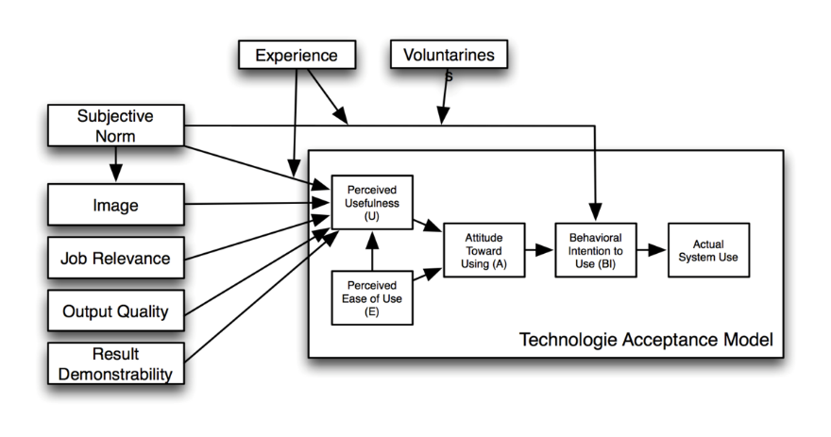
Figure 1: A Very Nice Figure

 | Treatment 1 | Treatment 2
Setting A | 125 | 95
Setting B | 85 | 102
Setting C | 98 | 85
Table 1. A Very Nice Table

- References:
- Font: Arial
- Size: 10
- Style: APA (6th ed.)
- Short bios:
- Font: Arial
- Size: 10

Writing style
As it is usually suggested by the Americas Conference on Information Systems (AMCIS), please pay attention to the following:
- Write for a general audience and present your work professionally.
- Write in a straightforward style. Try to avoid long or complex sentence structures.
- Briefly define or explain all technical terms that may be unfamiliar to readers.
- Explain all acronyms the first time they are used in your text – e.g., “Digital Library (DL).”
- Explain local references (e.g., not everyone knows all city names in a particular country).
- Be careful with the use of gender-specific pronouns (he, she) and other gendered words (chairman, manpower, man-months). Use inclusive, gender-neutral language (e.g., they, s/he, chair, staff, staff-hours, person-years).

References
All references and citations must follow the APA (6th ed.) style guidelines. Usage of reference managers, such as Zotero, Mendeley, and EndNote, is highly recommended. We present some examples of formatted citations and references below.

These are citations (Antonakis, Bendahan, & Lalive, 2014; Cavazotte, Moreno, & Hickmann, 2012; Davis, 1989; Kakhki & Palvia, 2016). Examples of how the references should be listed in the paper are given below.

Antonakis, J., Bendahan, S., & Lalive, R. (2014). Causality and endogeneity: Problems and solutions. In D. V. Day (Ed.), The Oxford handbook of leadership and organizations. New York: Oxford University Press.
Cavazotte, F., Moreno, V. de A., & Hickmann, M. (2012). Effects of leader intelligence, personality and emotional intelligence on transformational leadership and managerial performance. The Leadership Quarterly, 23, 443–455.
Davis, F. D. (1989). Perceived Usefulness, Perceived Ease of Use, and User Acceptance of Information Technology. MIS Quarterly, 13, 319–340.
Kakhki, M. D., & Palvia, P. (2016). Effect of Business Intelligence and Analytics on Business Performance. Proceedings of the XXII Americas Conference on Information Systems (AMCIS), 1–10. San Diego: Association for Information Systems (AIS).

Author’s name:
The author’s short bio should be no more than 100 words long. The photo is optional. If included, its size should be about 130 x 150 pixels.
Author’s name:
The author’s short bio should be no more than 100 words long. The photo is optional. If included, its size should be about 130 x 150 pixels.

Acknowledgements
Please acknowledge the persons, groups and organizations that were instrumental to the development of your research, if any.

