MISQE Manuscript Template
Use this template as the basis for writing your article. It is a guide of how to format your manuscript for MISQE.

In addition to your manuscript, there are three other important elements to include that will either be part of the article itself or used only on your article’s webpage.

- Keywords: Please list 3-5 keywords in order of importance.
- Executive Briefing: Briefly highlight the problem, key insights, and recommendations from your article so that digital leaders can quickly understand its premise. The Executive Briefing is featured as the first page of any article.
- Question-and-Answer section for answer engines: The inclusion of this information on your article’s web page will increase the chances of your paper being found via answer engines like ChatGPT and search engines with embedded AI search features, such as Google’s AI Overviews.

Manuscripts should be submitted without identifying the authors and structured as follows (see the following pages for formatting guidelines):
- Title page (title, abstract, keywords; author list and author affiliations to be added only after acceptance)
- Main text (literature cited will appear as footnotes), including:
  - Tables (with legends above each respective table)
  - Figures (with legends above each respective figure)
- Recommendations
- Concluding Comments
- Appendix: About the Research
- About the Authors (to be added after acceptance)

Executive Briefing: Article Title (this entire section should have no more than 400 words and is included in the overall word count limit)

THE KEY PROBLEM
- Describe the situation and the problem digital leaders are facing.
- (For example: Investments in digital technologies are at an all-time high, yet most digital investments do not yield the expected returns; thus, digital leaders need to understand what differentiates successful digital investments.)

KEY INSIGHTS
Based on… (In one sentence, describe the basis of the research; for example: “Based on an in-depth case study of Dutch health-technology company Royal Philips”).
- Provide the “aha” of your research; what are the key findings related to the problem?
- (For example: The five factors that differentiate successful digital innovation experiments from those that aren’t producing returns are (1)… (2) …
- There cannot be any references/footnotes in the entire Executive Briefing section.

WHAT EXECUTIVES SHOULD DO
- Provide the “so what?” of your findings: Now that leaders know about your findings, what should they do differently?
- These should be actionable recommendations. For example: Determine where your company stands with regard to the five success factors by …; Legitimize digital experimentation through …; Link the experiments to business value by ….
- Ideally, these directly match the recommendations you detail later in the article in the section “Recommendation for Digital Leaders”

MISQE Article Title should be about 15 words or less. It is called Article Title in the ribbon Styles Pane.
The summary paragraph (or abstract) is a short introduction (75-85 words) that gives a brief synopsis of the article. It is generally the second thing the reader will read after the heading. The font tends to be a bit larger, and there might be a footnote or two here that acknowledges the senior editor who accepted this article for publication. This style is called Summary Paragraph in this document’s Styles Pane.,

Author 1 (ONLY COMPLETE AUTHOR SECTION AFTER MANUSCRIPT IS ACCEPTED)
Affiliation (Country)

Author 2
Affiliation (Country)

Author 3
Affiliation (Country)

Author 4
Affiliation (Country)

Keywords (these will not be listed in article PDF but on its webpage)
Keyword 1, Keyword 2, Keyword 3, Keyword 4, Keyword 5

First level Heading: Major Section Subheading
MISQE articles have the following three levels of subheadings. The major section subheading (above) is called “Major Subheading” in the Ribbon (Figure 1).
Figure 1: The Microsoft Word ribbon view with custom named styles for MISQE

Second-Level Subheading: L2 Subhead
The second-level subheading above is called “L2 Subheading” in the Styles Pane. Again, the “MISQE Body” style follows.

Third-Level Subheading : L3 Subheading
Followed by normal body text. Body text (called Body MISQE in the Styles Pane) follows the subheadings. This will be the style for regular text within the article. If you need to italicize text in this body style, you can simply select the “I” button under the Home tab. Body text uses the Cambria font. If you don’t have this font installed on your computer, Word will automatically perform a font substitution. This is perfectly fine.
Here is an example of a block quote.

“Quotation from interviewee or research partner”—person attributed, job title, organization
Followed by normal body text (Body MISQE).

Citations and Footnotes
A reference to literature is cited as a footnote. Here is a real example of a footnote when citing an MISQE article. This is an example citing a Forbes article.
We strongly prefer that citations serve as explanations of references to our practitioner readers who will be less familiar than academics with the role of citations. References must be complete, and should include as appropriate, last name and initials of all authors, title, journal or web page, volume, number, month and year, publisher, city and state (for small publishers), editors, article page numbers, etc. A few examples are:
- One of the classic—and still relevant—articles that examines the problems introduced by information systems is Ackoff, R.L. "Management Misinformation Systems," Management Science (14:4), December 1961, pp. 147-156.
- For a good primer that explains the current wireless technologies and their business implications, see: Bates, R. J. Wireless Broadband Handbook, McGraw-Hill Professional Publishing, 2001.
- A related article that explores these issues in the Australian economy is Chenhall, R.H., and Romano, C.A. "Formal Planning and Control Presence and Impact on the Growth of Small Manufacturing Firms," in Job Generation by the Small Business Sector in Australia, Dunlop, W. C. and Williams, A. J. (eds.), Institute of Industrial Economics, Newcastle, 1989, pp. 71-89.
Some other examples of citations in footnotes are:
- Cavaye, A. L. M. “User participation in system development revisited,” Information and Management (28:5), May 1995, pp. 311-323.
- Carroll, N. and Maher, M. “How Shell Fueled a Digital Transformation by Establishing DIY Software Development,” MIS Quarterly Executive (22:2), June 2023, pp. 99-127.
- For more on the critical role of IT in obtaining both efficiencies and strategic success, see Sambamurthy, V., Bharadwaj, A. and Grover, V. “Shaping agility through digital options: Reconceptualizing the role of information technology in contemporary firms,” MIS Quarterly (27:2), 2003, pp. 237-263.
- Nadella, S. and Iansiti, M. Want a More Equitable Future? Empower Citizen Developers, Wired, December 9, 2020, available at https://www.wired.com/story/want-a-more-equitable-future-empower-citizen-developers/.
- Matvitskyy, O., Iijima, K., West, M., Davis, K., Jain, A. and Vincent, P. Magic Quadrant for Enterprise Low-Code Application Platforms, October 17, 2023, Gartner, Inc., available at https://www.gartner.com/en/documents/4843031?ref=null.
Note that, in footnotes, authors are listed first. Author names take the form: surname first, followed by initials, with a full stop after each initial and a space between initials. Use “and” (not &) before the last name of multiple authors. Papers and articles from a publication are written in plain text included in double quotes e.g., “Paper Title,” with a comma before the closing quote. The publication name itself is in italics. Ensure that capitalization of the title exactly matches that used in the published paper or article. The volume and issue number are written in the form (23:3) (for Volume 23, Issue 3). If the footnote references a standalone article or paper, the title is written in italics, with the publisher (which might be a website) in plain text. Include the publication date (month and year for a reference to a volume and issue, and full date in the form month day, year for a standalone article or paper). Also include the from and to page numbers in the form pp. 10-21 for journal articles. Where a web link is included, it is prefaced by “available at”.
For repeated footnote references, use:
- op. cit. = same as earlier reference (include authors and date). e.g., Novales, A. and Mancha, R., op. cit., September 2023.
- Ibid. = same as last reference

Bullet Point Lists
Here is an example of a bulleted list.
- First bullet point
- Second bullet point
Followed by normal body text (Body MISQE). Lorem ipsum dolor sit amet, consectetur adipiscing elit, sed do eiusmod tempor incididunt ut labore et dolore magna aliqua. Ut enim ad minim veniam, quis nostrud exercitation ullamco laboris nisi ut aliquip ex…

Figures and Tables
The Figure or Table header (same style for both) goes above the image of a figure or table, which will span two columns when typeset (see Figure 2 below). It is called “Table/Figure Caption” in the Styles Pane and is left-justified in Times New Roman font. For the final version of your accepted manuscript, please make sure that you have included a high-resolution copy (not embedded in the manuscript) of all figures; each figure should be in a separate file. If a footnote is required for a table, it will be placed within it as the last row.
Figure 2: Sample Figure of What Figures Will Look Like in the PDF
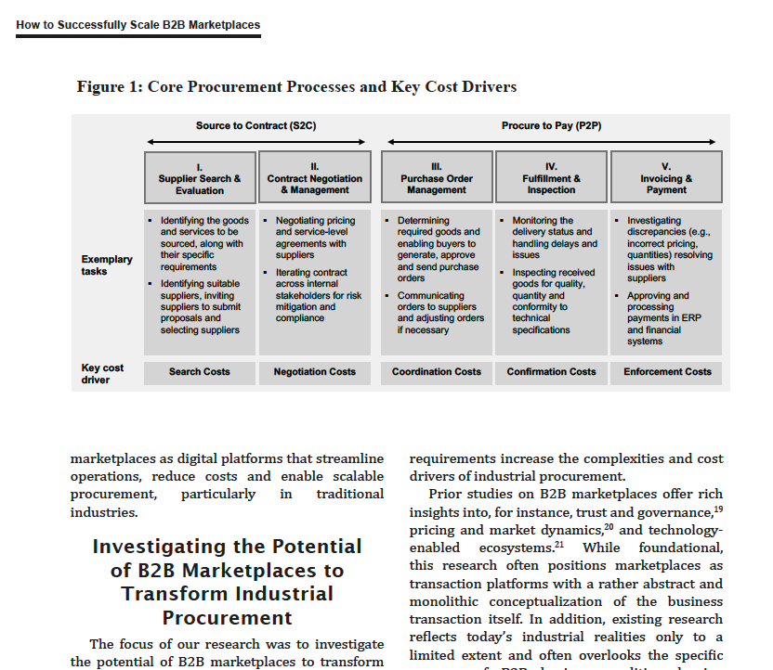
Above is an example of a figure when typeset. Figures will always span two columns.

Table 1: Table Caption for Sample Table

Table Header | Table Header
Please be aware that your table will be formatted in a two-column page layout when typeset. This means that your table may not appear on the same page it is referenced, especially if there are many tables/figures close together. The reference in the text will always precede the Table or Figure.¹ | Please do not change the page orientation to landscape for big tables. It will likely not fit on the typeset page if you have resort to this to get the table to fit.
¹If you have a footnote in your table, it will be placed on the last row of your table.

Recommendations for Digital Leaders
All MISQE articles are suppose to have a section Recommendations for Digital Leaders. If your recommendations target a more specific group (e.g., CIOs), name that group instead of “Digital Leaders.”

Recommendation 1 (Style name is ‘Recommendation’ in Ribbon)
Instead of writing “Recommendation 1,” “Recommendation 2,” etc. you would provide your actual recommendation. Lorem ipsum dolor sit amet, consectetur adipiscing elit, sed do eiusmod tempor incididunt ut labore et dolore magna aliqua. Ut enim ad minim veniam, quis nostrud exercitation ullamco laboris nisi ut aliquip ex…

Recommendation 2
Followed by normal body text (Body MISQE). Lorem ipsum dolor sit amet, consectetur adipiscing elit, sed do eiusmod tempor incididunt ut labore et dolore magna aliqua. Ut enim ad minim veniam, quis nostrud exercitation ullamco laboris nisi ut aliquip …

Recommendation 3
Followed by normal body text (Body MISQE). Lorem ipsum dolor sit amet, consectetur adipiscing elit, sed do eiusmod tempor incididunt ut labore et dolore magna aliqua. Ut enim ad minim veniam, quis nostrud exercitation ullamco laboris nisi ut aliquip …

Concluding Comments
All MISQE articles have a Concluding Comments section. This section typically comprises two or three paragraphs summarizing the main points in the article. It should not include any new material.

Appendix: About the Research
The Appendix must be explicitly referenced in the text. If there are multiple appendices, they are labeled Appendix A, Appendix B, Appendix C, etc. If there are multiple figures or tables that apply to Appendix A, use the following naming convention: Figure A1: Title of Figure.

The first (and possible the only) Appendix will be About the Research, which should describe your research approach as succinctly as possible for digital leaders.

About the Authors
Only include after your article is accepted. Note that the numbers of words used in this section count toward the overall article limit of 7,500 words for research articles and 3,500 words for MISQE Insight articles.

Author 1
Author 1 (email address) is … The maximum length for this paragraph is 100 words. Any publications mentioned must be spelled out in full.

Author 2
Author 2 (email address) is … The maximum length for this paragraph is 100 words. Any publications mentioned must be spelled out in full.

Author 3
Author 3 (email address) is … The maximum length for this paragraph is 100 words. Any publications mentioned must be spelled out in full.

Author 4
Author 4 (email address) is … The maximum length for this paragraph is 100 words. Any publications mentioned must be spelled out in full.

Question-and-Answer Section for Answer Engines
MISQE targets digital leaders and wants to help your research reach that target audience.
To make it easy for answer engines (like ChatGPT search, Perplexity, and Google AI Overviews) to find relevant information, please provide three sets of questions and answers that are relevant to your article. We will extract this section from the article during the production stage, and it will not become part of the article PDF. This section does not count toward the overall word count limit.

For example:

What are the key factors differentiating successful digital investments?
Five factors differentiate successful digital investments from less successful ones: (1)… (2)… (3)…

Another question that digital leaders might ask?
Answer provided by your research.

A third question that digital leaders might ask?
Answer provided by your research.

Xxxx is the senior accepting editor for this article. This is Times New Roman 8 pt. (Complete after acceptance.)
Put any acknowledgements and funding sources in this footnote; delete it if not needed. Make sure to maintain anonymity until your article is accepted.
LastName, Initial., LastName, Initial. and LastName, Initial. “Title of Article,” Name of Journal (Vol:Issue) or Date, Year.
Proudfoot, J.G., Cram, W.A., Madnick, S. and Coden, M. “The Importance of Board Member Actions for Cybersecurity Governance and Risk Management,” MIS Quarterly Executive (22:4), 2023.
Fadeyi, K. “AI In Cybersecurity: Revolutionizing Safety,” Forbes, February 15, 2024.

