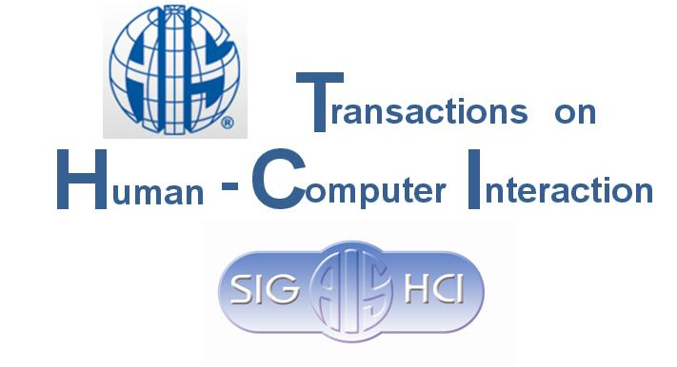 | Copyright Release Form

To: (Authors’ names)
From: Dennis Galletta and Ping Zhang, Editors of AIS THCI
Subject: Transfer of Copyright Agreement
Congratulations on your paper “Paper TItle” being accepted for AIS THCI. Before we can publish the paper, THCI requires that you release copyright to The Association for Information Systems. Please fill in and sign the following page and return it via postal mail (or PDF as an e-mail attachment) to:
Dr. Ping Zhang
AIS Transactions on Human-Computer Interaction
Hinds 328
School of Information Studies
Syracuse University
Syracuse, NY 13244
All authors must sign the form. Individual authors can send this form individually if they are not located in the same place. Thank you for your quick response in this matter.

Note: Each article of AIS THCI will contain the following statement inside the paper regarding the copyright of material.
Copyright © 2009 [or the year the paper is published], by the Association for Information Systems. Permission to make digital or hard copies of all or part of this work for personal or classroom use is granted without fee provided that copies are not made or distributed for profit or commercial advantage and that copies bear this notice and full citation on the first page. Copyright for components of this work owned by others than the Association for Information Systems must be honored. Abstracting with credit is permitted. To copy otherwise, to republish, to post on servers for commercial use, or to redistribute to lists requires prior specific permission and/or fee. Request permission to publish from: AIS Administrative Office, P.O. Box 2712 Atlanta, GA, 30301-2712 Attn: Reprints, or via e-mail from ais@aisnet.org.

Transfer of Copyright Agreement
I, the undersigned, declare that the article entitled:
(Paper title)
is original, and that I (as author or co-author) hold exclusive copyright of the material. I hereby transfer exclusive copyright for this material to the Association for Information Systems through the publication, AIS Transactions on Human-Computer Interaction. The following rights are reserved by the author(s):
- The right to use, free of charge, all or part of this article in future works of their own, such as books and lectures, giving reference to the original place of publication and copyright holding.
- Authors may include a copy of their article on their Web page as long as it is clearly noted that the Association for Information Systems owns the copyright and that use for profit is not allowed. Such an author version must be identical to the final published version, and include a link to the Communications of AIS.
- Electronic or print copies may be made for non-commercial personal or classroom use. In cases of classroom copies, copyright should be attributed to AIS on each copy.

Name:
Title/Rank:
Telephone:
e-mail:
Address:

Signature: _______________________________ Date: ________________

